HEURISTIC SEARCH TECHNIQUES:

Search Algorithms
Many traditional search algorithms are used in AI applications. For complex problems, the traditional algorithms are unable to find the solutions within some practical time and space limits. Consequently, many special techniques are developed, using heuristic functions. The algorithms that use heuristic functions are called heuristic algorithms.
• Heuristic algorithms are not really intelligent; they appear to be intelligent because they achieve better performance.
• Heuristic algorithms are more efficient because they take advantage of feedback from the data to direct the search path.
• Uninformed search algorithms or Brute-force algorithms, search through the search space all
possible candidates for the solution checking whether each candidate satisfies the problem’s
statement.
• Informed search algorithms use heuristic functions that are specific to the problem, apply
them to guide the search through the search space to try to reduce the amount of time spent in
searching.
A good heuristic will make an informed search dramatically outperform any uninformed search: for example, the Traveling Salesman Problem (TSP), where the goal is to find is a good solution instead of finding the best solution.
In such problems, the search proceeds using current information about the problem to predict which path is closer to the goal and follow it, although it does not always guarantee to find the best possible solution. Such techniques help in finding a solution within reasonable time and space (memory). Some prominent intelligent search algorithms are stated below:
1. Generate and Test Search
2. Best-first Search
3. Greedy Search
4. A* Search
5. Constraint Search
6. Means-ends analysis
There are some more algorithms. They are either improvements or combinations of these.
• Hierarchical Representation of Search Algorithms: A Hierarchical representation of most
search algorithms is illustrated below. The representation begins with two types of search:
• Uninformed Search: Also called blind, exhaustive or brute-force search, it uses no
information about the problem to guide the search and therefore may not be very efficient.
• Informed Search: Also called heuristic or intelligent search, this uses information about the problem to guide the search—usually guesses the distance to a goal state and is therefore
efficient, but the search may not be always possible.

32

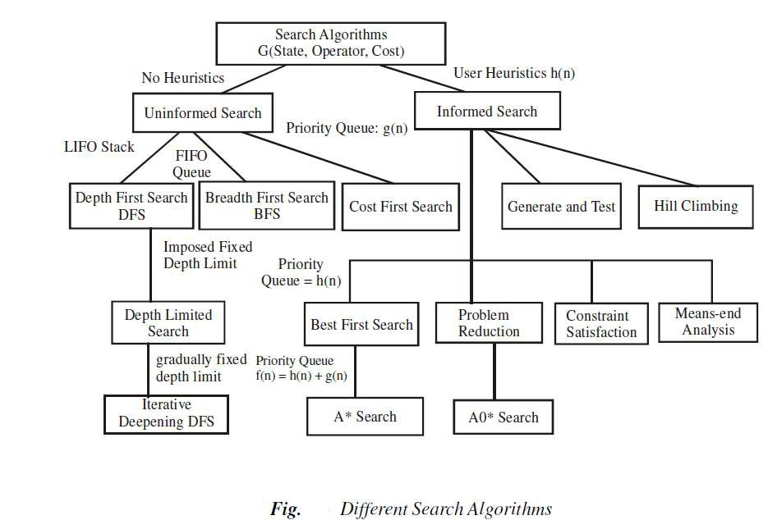

The first requirement is that it causes motion, in a game playing program, it moves on the board and in the water jug problem, filling water is used to fill jugs. It means the control strategies without the motion will never lead to the solution.
The second requirement is that it is systematic, that is, it corresponds to the need for global
motion as well as for local motion. This is a clear condition that neither would it be rational to fill a jug and empty it repeatedly, nor it would be worthwhile to move a piece round and round on the board in a cyclic way in a game. We shall initially consider two systematic approaches for searching. Searches can be classified by the order in which operators are tried: depth-first,
breadth-first, bounded depth-first.

33

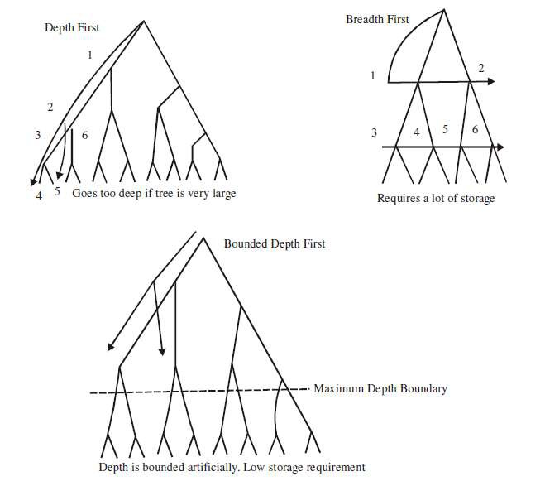

Breadth-first search
A Search strategy, in which the highest layer of a decision tree is searched completely before proceeding to the next layer is called Breadth-first search (BFS).
• In this strategy, no viable solutions are omitted and therefore it is guaranteed that an optimal solution is found.
• This strategy is often not feasible when the search space is large.
Algorithm
1. Create a variable called LIST and set it to be the starting state.
2. Loop until a goal state is found or LIST is empty, Do
a. Remove the first element from the LIST and call it E. If the LIST is empty, quit.
b. For every path each rule can match the state E, Do
(i) Apply the rule to generate a new state.
(ii) If the new state is a goal state, quit and return this state. (iii) Otherwise, add the new state to the end of LIST.

34

Advantages
1. Guaranteed to find an optimal solution (in terms of shortest number of steps to reach the goal).
2. Can always find a goal node if one exists (complete).
Disadvantages
1. High storage requirement: exponential with tree depth. Depth-first search
A search strategy that extends the current path as far as possible before backtracking to the last choice point and trying the next alternative path is called Depth-first search (DFS).
• This strategy does not guarantee that the optimal solution has been found.
• In this strategy, search reaches a satisfactory solution more rapidly than breadth first, an advantage when the search space is large.
Algorithm
Depth-first search applies operators to each newly generated state, trying to drive directly toward
the goal.
1. If the starting state is a goal state, quit and return success.
2. Otherwise, do the following until success or failure is signalled:
a. Generate a successor E to the starting state. If there are no more successors, then signal failure.
b. Call Depth-first Search with E as the starting state.
c. If success is returned signal success; otherwise, continue in the loop.
Advantages
1. Low storage requirement: linear with tree depth.
2. Easily programmed: function call stack does most of the work of maintaining state of the
search.
Disadvantages
1. May find a sub-optimal solution (one that is deeper or more costly than the best solution).
2. Incomplete: without a depth bound, may not find a solution even if one exists.
2.4.2.3 Bounded depth-first search
Depth-first search can spend much time (perhaps infinite time) exploring a very deep path that does not contain a solution, when a shallow solution exists. An easy way to solve this problem is to put a maximum depth bound on the search. Beyond the depth bound, a failure is generated automatically without exploring any deeper.
Problems:
1. It’s hard to guess how deep the solution lies.
2. If the estimated depth is too deep (even by 1) the computer time used is dramatically increased, by a factor of bextra.
3. If the estimated depth is too shallow, the search fails to find a solution; all that computer time
is wasted.

Heuristics
A heuristic is a method that improves the efficiency of the search process. These are like tour
guides. There are good to the level that they may neglect the points in general interesting
directions; they are bad to the level that they may neglect points of interest to particular
individuals. Some heuristics help in the search process without sacrificing any claims to entirety
that the process might previously had. Others may occasionally cause an excellent path to be
overlooked. By sacrificing entirety it increases efficiency. Heuristics may not find the best

35

solution every time but guarantee that they find a good solution in a reasonable time. These are
particularly useful in solving tough and complex problems, solutions of which would require
infinite time, i.e. far longer than a lifetime for the problems which are not solved in any other
way.
Heuristic search
To find a solution in proper time rather than a complete solution in unlimited time we use
heuristics. ‘A heuristic function is a function that maps from problem state descriptions to
measures of desirability, usually represented as numbers’. Heuristic search methods use
knowledge about the problem domain and choose promising operators first. These heuristic
search methods use heuristic functions to evaluate the next state towards the goal state. For
finding a solution, by using the heuristic technique, one should carry out the following steps:
1. Add domain—specific information to select what is the best path to continue searching along.
2. Define a heuristic function h(n) that estimates the ‘goodness’ of a node n.
Specifically, h(n) = estimated cost(or distance) of minimal cost path from n to a goal state.
3. The term, heuristic means ‘serving to aid discovery’ and is an estimate, based on domain
specific information that is computable from the current state description of how close we are to
a goal.
Finding a route from one city to another city is an example of a search problem in which different search orders and the use of heuristic knowledge are easily understood.
1. State: The current city in which the traveller is located.
2. Operators: Roads linking the current city to other cities.
3. Cost Metric: The cost of taking a given road between cities.
4. Heuristic information: The search could be guided by the direction of the goal city from the current city, or we could use airline distance as an estimate of the distance to the goal.
Heuristic search techniques
For complex problems, the traditional algorithms, presented above, are unable to find the
solution within some practical time and space limits. Consequently, many special techniques are developed, using heuristic functions.
• Blind search is not always possible, because it requires too much time or Space (memory).
Heuristics are rules of thumb; they do not guarantee a solution to a problem.
• Heuristic Search is a weak technique but can be effective if applied correctly; it requires domain specific information.

Characteristics of heuristic search
• Heuristics are knowledge about domain, which help search and reasoning in its domain.
• Heuristic search incorporates domain knowledge to improve efficiency over blind search.
• Heuristic is a function that, when applied to a state, returns value as estimated merit of state, with respect to goal.
✓ Heuristics might (for reasons) underestimate or overestimate the merit of a state with
respect to goal.
✓ Heuristics that underestimate are desirable and called admissible.
• Heuristic evaluation function estimates likelihood of given state leading to goal state.
• Heuristic search function estimates cost from current state to goal, presuming function is
efficient.

36

Heuristic search compared with other search
The Heuristic search is compared with Brute force or Blind search techniques below:

Comparison of Algorithms

Brute force / Blind search
Can only search what it has knowledge about already
No knowledge about how far a node node from goal state

Example: Travelling salesman

Heuristic search
Estimates ‘distance’ to goal state through explored nodes
Guides search process toward goal

Prefers states (nodes) that lead
close to and not away from goal
state

A salesman has to visit a list of cities and he must visit each city only once. There are different routes between the cities. The problem is to find the shortest route between the cities so that the salesman visits all the cities at once.
Suppose there are N cities, then a solution would be to take N! possible combinations to find the shortest distance to decide the required route. This is not efficient as with N=10 there are
36,28,800 possible routes. This is an example of combinatorial explosion.
There are better methods for the solution of such problems: one is called branch and bound.
First, generate all the complete paths and find the distance of the first complete path. If the next path is shorter, then save it and proceed this way avoiding the path when its length exceeds the saved shortest path length, although it is better than the previous method.
Generate and Test Strategy

Generate-And-Test Algorithm
Generate-and-test search algorithm is a very simple algorithm that guarantees to find a solution if done systematically and there exists a solution.
Algorithm: Generate-And-Test
1.Generate a possible solution.
2.Test to see if this is the expected solution.
3.If the solution has been found quit else go to step 1.
Potential solutions that need to be generated vary depending on the kinds of problems. For some problems the possible solutions may be particular points in the problem space and for some problems, paths from the start state.

37

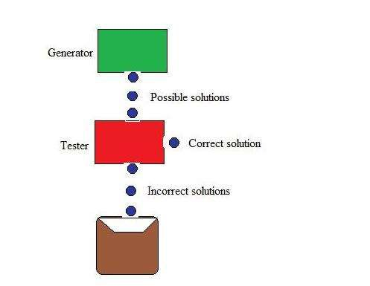

Figure: Generate And Test
Generate-and-test, like depth-first search, requires that complete solutions be generated for
testing. In its most systematic form, it is only an exhaustive search of the problem space.
Solutions can also be generated randomly but solution is not guaranteed. This approach is what is
known as British Museum algorithm: finding an object in the British Museum by wandering
randomly.
Systematic Generate-And-Test
While generating complete solutions and generating random solutions are the two extremes there exists another approach that lies in between. The approach is that the search process proceeds systematically but some paths that unlikely to lead the solution are not considered. This
evaluation is performed by a heuristic function.
Depth-first search tree with backtracking can be used to implement systematic generate-and-test procedure. As per this procedure, if some intermediate states are likely to appear often in the tree, it would be better to modify that procedure to traverse a graph rather than a tree.
Generate-And-Test And Planning
Exhaustive generate-and-test is very useful for simple problems. But for complex problems even heuristic generate-and-test is not very effective technique. But this may be made effective by
combining with other techniques in such a way that the space in which to search is restricted. An AI program DENDRAL, for example, uses plan-Generate-and-test technique. First, the planning process uses constraint-satisfaction techniques and creates lists of recommended and
contraindicated substructures. Then the generate-and-test procedure uses the lists generated and required to explore only a limited set of structures. Constrained in this way, generate-and-test proved highly effective. A major weakness of planning is that it often produces inaccurate
solutions as there is no feedback from the world. But if it is used to produce only pieces of
solutions then lack of detailed accuracy becomes unimportant.

38

Hill Climbing
Hill Climbing is heuristic search used for mathematical optimization problems in the field of Artificial Intelligence .
Given a large set of inputs and a good heuristic function, it tries to find a sufficiently good
solution to the problem. This solution may not be the global optimal maximum.
▪ In the above definition, mathematical optimization problems implies that hill climbing
solves the problems where we need to maximize or minimize a given real function by
choosing values from the given inputs. Example-Travelling salesman problem where we
need to minimize the distance traveled by salesman.
▪ ‘Heuristic search’ means that this search algorithm may not find the optimal solution to
the problem. However, it will give a good solution in reasonable time.
▪ A heuristic function is a function that will rank all the possible alternatives at any
branching step in search algorithm based on the available information. It helps the
algorithm to select the best route out of possible routes.
Features of Hill Climbing
1. Variant of generate and test algorithm : It is a variant of generate and test algorithm. The
generate and test algorithm is as follows :

1. Generate a possible solutions.
2. Test to see if this is the expected solution.
3. If the solution has been found quit else go to step 1.
Hence we call Hill climbing as a variant of generate and test algorithm as it takes the feedback
from test procedure. Then this feedback is utilized by the generator in deciding the next move in
search space.
2. Uses the Greedy approach : At any point in state space, the search moves in that direction
only which optimizes the cost of function with the hope of finding the optimal solution at
the end.
Types of Hill Climbing

1. Simple Hill climbing : It examines the neighboring nodes one by one and selects the first
neighboring node which optimizes the current cost as next node.
Algorithm for Simple Hill climbing :
Step 1 : Evaluate the initial state. If it is a goal state then stop and return success. Otherwise, make initial state as current state.
Step 2 : Loop until the solution state is found or there are no new operators present which can be applied to current state.
a) Select a state that has not been yet applied to the current state and apply it to produce a new
state.
b) Perform these to evaluate new state
i. If the current state is a goal state, then stop and return success.
ii. If it is better than the current state, then make it current state and proceed further.
iii. If it is not better than the current state, then continue in the loop until a solution is found.

Step 3 : Exit.

39

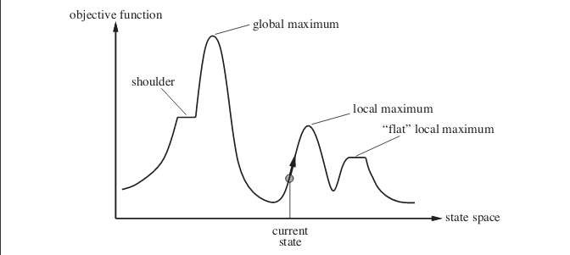
2. Steepest-Ascent Hill climbing : It first examines all the neighboring nodes and then
selects the node closest to the solution state as next node.
Step 1 : Evaluate the initial state. If it is goal state then exit else make the current state as initial
state
Step 2 : Repeat these steps until a solution is found or current state does not change
i. Let ‘target’ be a state such that any successor of the current state will be better than it; ii. for each operator that applies to the current state
a. apply the new operator and create a new state
b. evaluate the new state
c. if this state is goal state then quit else compare with ‘target’
d. if this state is better than ‘target’, set this state as ‘target’
e. if target is better than current state set current state to Target Step 3 : Exit
3. Stochastic hill climbing : It does not examine all the neighboring nodes before deciding
which node to select .It just selects a neighboring node at random, and decides (based on
the amount of improvement in that neighbor) whether to move to that neighbor or to examine another.
State Space diagram for Hill Climbing
State space diagram is a graphical representation of the set of states our search algorithm can
reach vs the value of our objective function(the function which we wish to maximize).
X-axis : denotes the state space ie states or configuration our algorithm may reach.
Y-axis : denotes the values of objective function corresponding to to a particular state.
The best solution will be that state space where objective function has maximum value(global
maximum).

Different regions in the State Space Diagram
1. Local maximum : It is a state which is better than its neighboring state however there
exists a state which is better than it(global maximum). This state is better because here
value of objective function is higher than its neighbors.

40

2. Global maximum : It is the best possible state in the state space diagram. This because at
this state, objective function has highest value.
3. Plateua/flat local maximum : It is a flat region of state space where neighboring states
have the same value.
4. Ridge : It is region which is higher than its neighbours but itself has a slope. It is a special
kind of local maximum.
5. Current state : The region of state space diagram where we are currently present during
the search.
6. Shoulder : It is a plateau that has an uphill edge. Problems in different regions in Hill climbing
Hill climbing cannot reach the optimal/best state(global maximum) if it enters any of the following regions :
1. Local maximum : At a local maximum all neighboring states have a values which is
worse than than the current state. Since hill climbing uses greedy approach, it will not
move to the worse state and terminate itself. The process will end even though a better solution may exist.
To overcome local maximum problem : Utilize backtracking technique. Maintain a list of visited states. If the search reaches an undesirable state, it can backtrack to the previous configuration and explore a new path.
2. Plateau : On plateau all neighbors have same value . Hence, it is not possible to select the
best direction.
To overcome plateaus : Make a big jump. Randomly select a state far away from current state. Chances are that we will land at a non-plateau region
3. Ridge : Any point on a ridge can look like peak because movement in all possible
directions is downward. Hence the algorithm stops when it reaches this state.
To overcome Ridge : In this kind of obstacle, use two or more rules before testing. It implies moving in several directions at once.
Best First Search (Informed Search)
In BFS and DFS, when we are at a node, we can consider any of the adjacent as next
node. So both BFS and DFS blindly explore paths without considering any cost function. The
idea of Best First Search is to use an evaluation function to decide which adjacent is most
promising and then explore. Best First Search falls under the category of Heuristic Search or
Informed Search.
We use a priority queue to store costs of nodes. So the implementation is a variation of BFS, we just need to change Queue to PriorityQueue.
Algorithm:
Best-First-Search(Grah g, Node start)
1) Create an empty PriorityQueue PriorityQueue pq;
2) Insert "start" in pq. pq.insert(start)
3) Until PriorityQueue is empty
u = PriorityQueue.DeleteMin

41

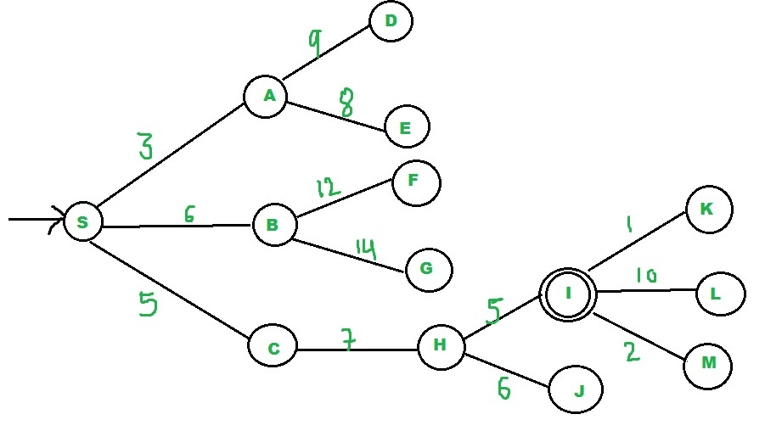
If u is the goal
Exit
Else
Foreach neighbor v of u If v "Unvisited"
Mark v "Visited" pq.insert(v)
Mark v "Examined" End procedure
Let us consider below example.

We start from source "S" and search for
goal "I" using given costs and Best
First search.

pq initially contains S
We remove s from and process unvisited neighbors of S to pq.
pq now contains {A, C, B} (C is put
before B because C has lesser cost)
We remove A from pq and process unvisited neighbors of A to pq.
pq now contains {C, B, E, D}

42

We remove C from pq and process unvisited neighbors of C to pq.
pq now contains {B, H, E, D}
We remove B from pq and process unvisited neighbors of B to pq.
pq now contains {H, E, D, F, G}

We remove H from pq. Since our goal "I" is a neighbor of H, we return.
Analysis :
▪ The worst case time complexity for Best First Search is O(n * Log n) where n is number
of nodes. In worst case, we may have to visit all nodes before we reach goal. Note that
priority queue is implemented using Min(or Max) Heap, and insert and remove operations take O(log n) time.
▪ Performance of the algorithm depends on how well the cost or evaluation function is
designed.

